|  |  |  |
| --- | --- | --- |
|  | Headway  East Lothian  SC10  Newsletter  [www.headway-eastlothian.org.uk](http://www.headway-eastlothian.org.uk/) |  |
| Issue 17/03 |  | March 2017 |



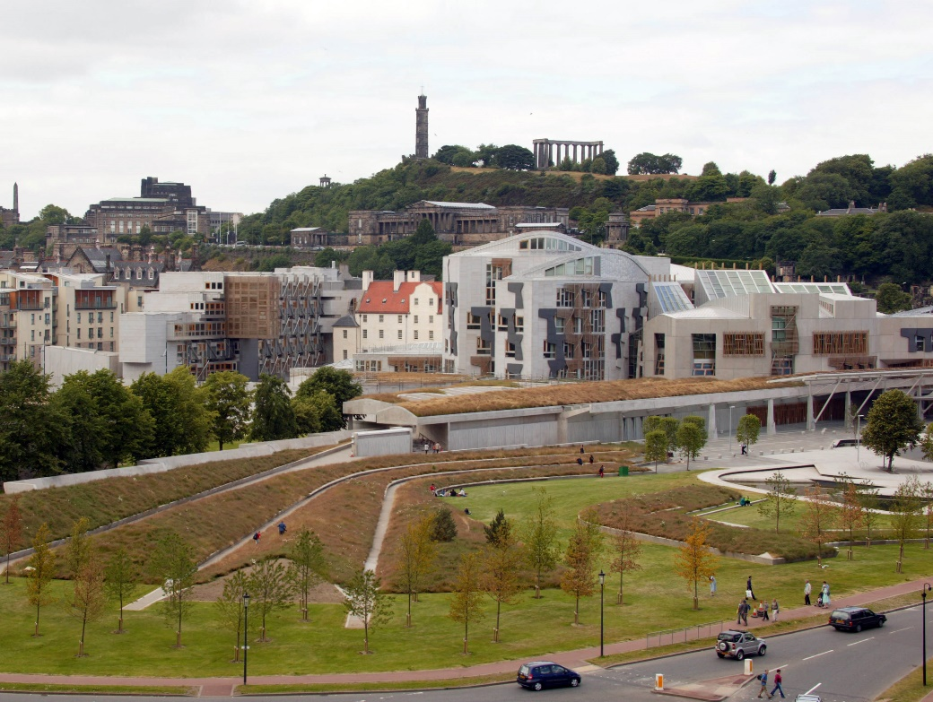

Look forward to a visit to the Scottish Parliament

on Friday

31st March.

|  |
| --- |
| Lloyds TSB Foundation  awards-for-all-logo |

Noticeboard

|  |  |
| --- | --- |
|  | Carer meetings held on Mondays as required |
|  | Relaxation classes held on Mondays as required |
| E:\2009-03-27, pdrc eyemouth\pdrc eyemouth 002.jpg | Next Outing  Scottish Parliament  Friday 31st March |
| meeting-room | Next Board Meeting  Wednesday 8th March  Haddington |

Daniel Alison, Story-teller

We are pleased to welcome Daniel to Headway East Lothian and he will be with us on the following days.

Haddington Wednesday 22nd March

Musselburgh Monday 27th March

Daniel is no stranger to Headway and he is sure to hold our attention with stories he has collected on his travels.

They promise to be entertaining so come along and join us.

Outreach Service

Don’t forget about our Outreach service. If you are unable to come to Headway meetings and need anything attended to Joyce will be pleased to come along to see you at home.



**2017 SHIF Events**

**Thursday 30th March - Prolonged Disorders of Consciousness & SHIF AGM (Edinburgh City Chambers)**

**Thursday 21st September - Who's Who? - The A - Z of ABI**

**(Dumfries, venue TBC)**

**Thursday 30th November - ABI - The Scottish Perspective**

**(Glasgow, venue TBC)**

Wednesday 8th March Haddington

The Board Meeting that night will take place

at one end of the hall while the

film ”Whisky Galore” will be shown at the other end.

This month at Headway

|  |  |  |  |
| --- | --- | --- | --- |
| 1 | Wed | Haddington | You Choose |
| 2 | Thu | Dunbar | March Marches in |
| 3 | Fri |  |  |
| 4 | Sat |  |  |
| 5 | Sun |  |  |
| 6 | Mon | Musselburgh | New Age Kurling |
| 7 | Tues |  |  |
| 8 | Wed | Haddington | Board meeting Film / Whisky Galore |
| 9 | Thu | Dunbar | New Age Kurling |
| 10 | Fri |  |  |
| 11 | Sat |  |  |
| 12 | Sun |  |  |
| 13 | Mon | Musselburgh | Quizzes, Chat & dominoes - Joyce |
| 14 | Tues |  |  |
| 15 | Wed | Haddington |  |
| 16 | Thu | Dunbar | Storytelling the Headway way |
| 17 | Fri |  |  |
| 18 | Sat |  |  |
| 19 | Sun |  |  |
| 20 | Mon | Musselburgh | Carers in the Cafe |
| 21 | Tues | Glasgow | SDC Meeting |
| 22 | Wed | Haddington | Daniel Allison – Storyteller |
| 23 | Thu | Dunbar | Puzzles & quizzes |
| 24 | Fri |  |  |
| 25 | Sat |  |  |
| 26 | Sun |  |  |
| 27 | Mon | Musselburgh | Daniel Allison – Storyteller |
| 28 | Tues |  |  |
| 29 | Wed | Haddington |  |
| 30 | Thu | Dunbar/Edinburgh | Games/SHIF Conference |
| 31 | Fri | Outing | Scottish Parliament |

Meetings

**Monday T**he Musselburgh East Community Association (MECA) building,

Wallyford Road, just up from Levenhall roundabout 1pm - 4pm. A chance to meet over a cup of coffee. There is a café where lunch or a snack can be purchased.

**Wednesday T**he Doughty Centre Herdmanflat Hospital Aberlady Road Haddington at 6.30pm Wednesday evenings with a speaker etc. The meeting finishes at 8.30pm. We are not connected to the hospital.

**Thursday** we meet at Hallhill Healthy Living Centre, Dunbar on a Thursday

12 noon- 2pm for those who live in Dunbar and surrounding area.

Contact Us

|  |  |
| --- | --- |
| Jim Maryniak  Convener | 07920 195743  [jimmaryniak@hotmail.com](mailto:jimmaryniak@hotmail.com) |
| Richard Fairbairn  Treasurer | 077604 95851  [james.fairbairn123@btinternet.com](mailto:james.fairbairn123@btinternet.com) |
|  |  |
|  |  |
| Development Officer  Joyce Cattanach | 07895 193974  [headwayeastlothian@live.co.uk](mailto:headwayeastlothian@live.co.uk) |

Joyce is also available at The Bleachingfield Centre, Countess Crescent, Dunbar, EH42 1DX, by appointment, Mondays, Tuesdays & Wednesdays and for outreach at other times.

Items for the newsletter to Robert Dalrymple [robert.dalrymple202@btinternet.com](mailto:robert.dalrymple202@btinternet.com?subject=Newsletter%20Item) Tel 01620 844020



Improving life after brain injury Charity No **SC035535**

Next Board

Meeting



1.30 pm MECA

in January tbc