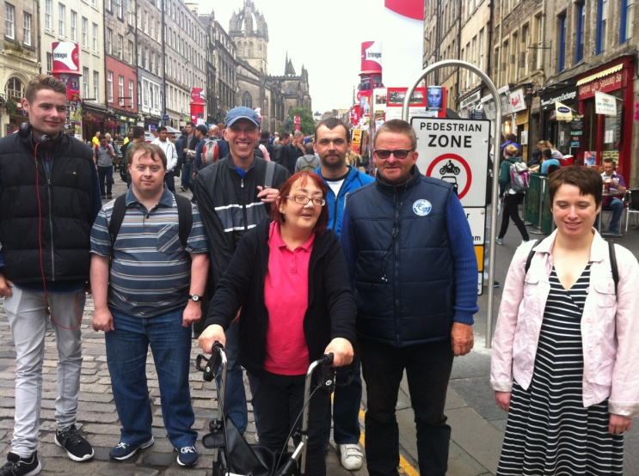
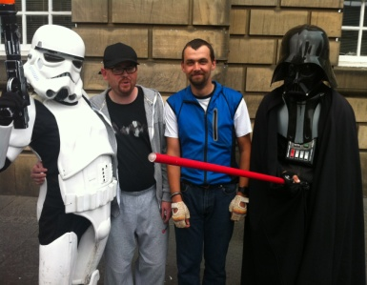
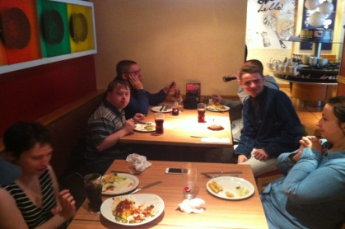

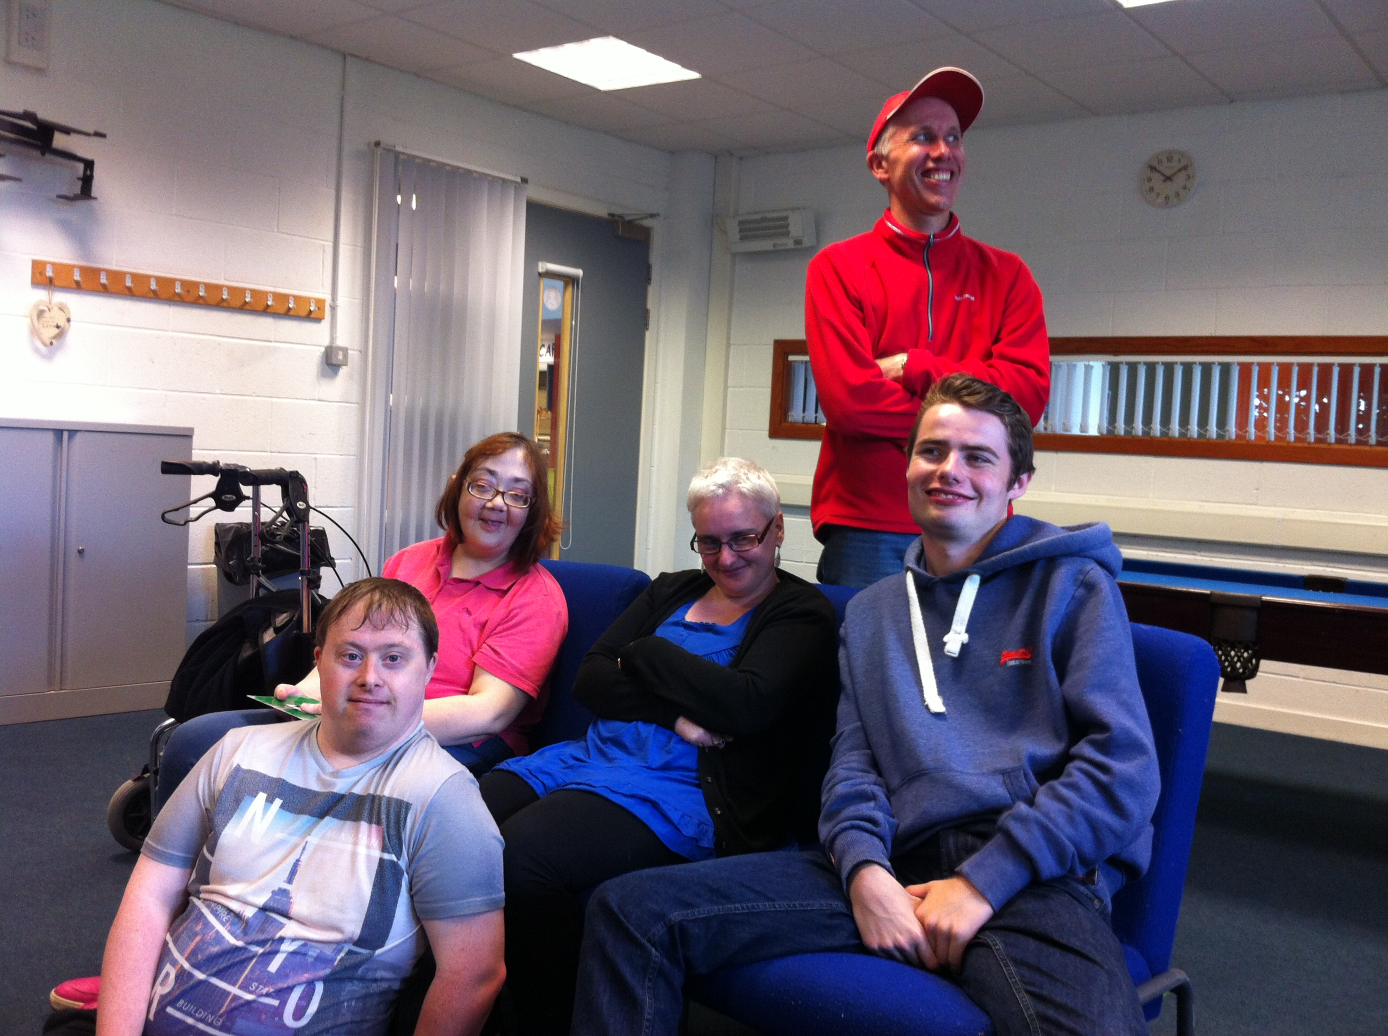
Some snaps from Smart Talk’s Day Out at Edinburgh Fringe

The Smart Talk meetings in Musselburgh have now started. We meet in The MECA Centre every second Wednesday. New members are welcome to join us. We meet 1-3pm.
Summer News
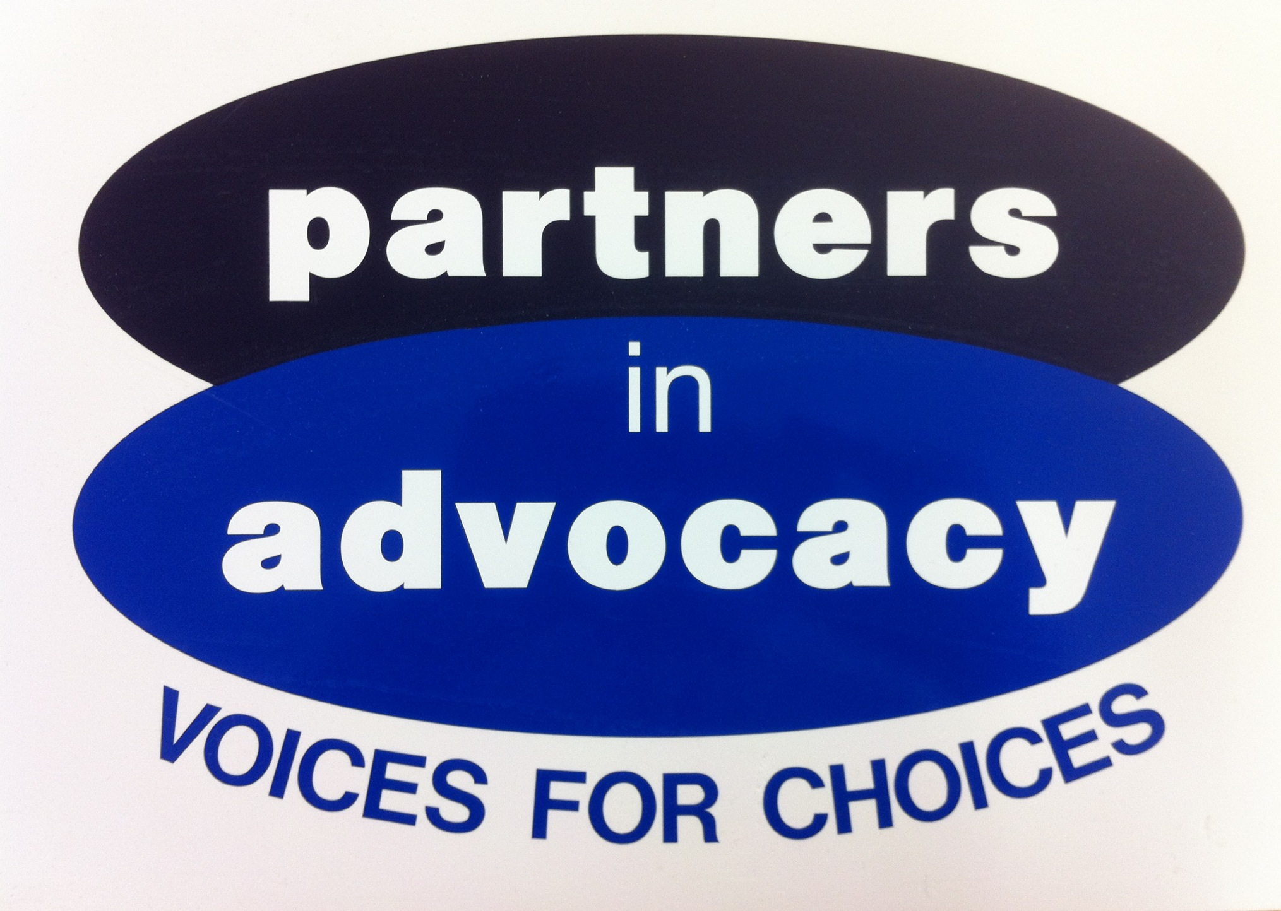 SMART TALK
NEWSLETTER – August 2016
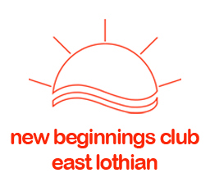
the nbc had a good barbeque at the tranent allotment recently. several smart talk members were there for some great grub.
The nbc also had their annual sponsored walk around arthur seat this month.
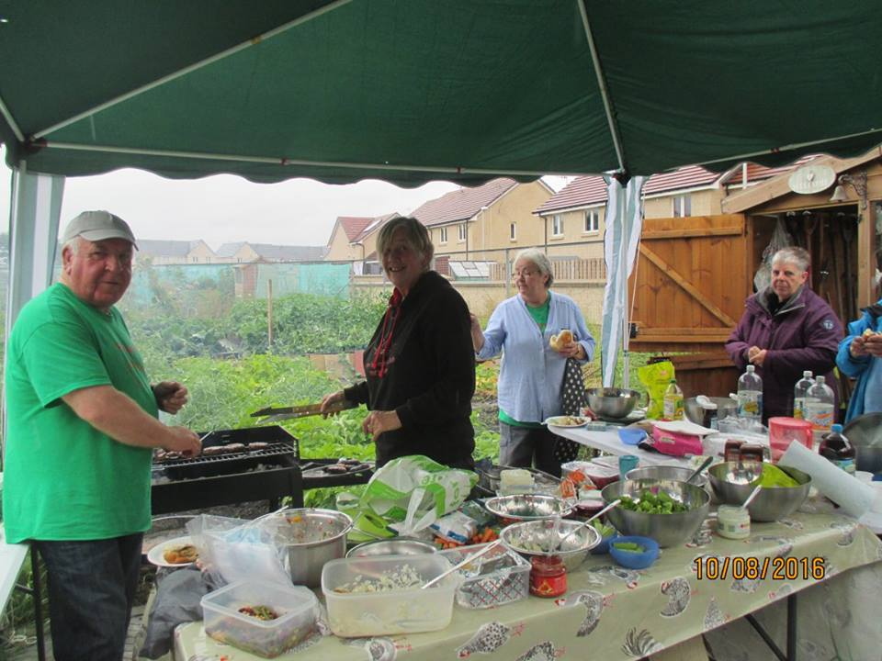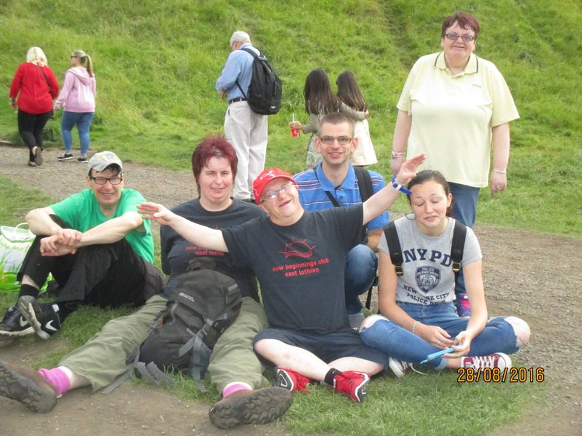

many of the smart talk members have been dancing away at the cav again. being a part of get2gether seems a lot of fun. Katrina, Ryan, Mhairi, Michael and sarah have been boogieing.
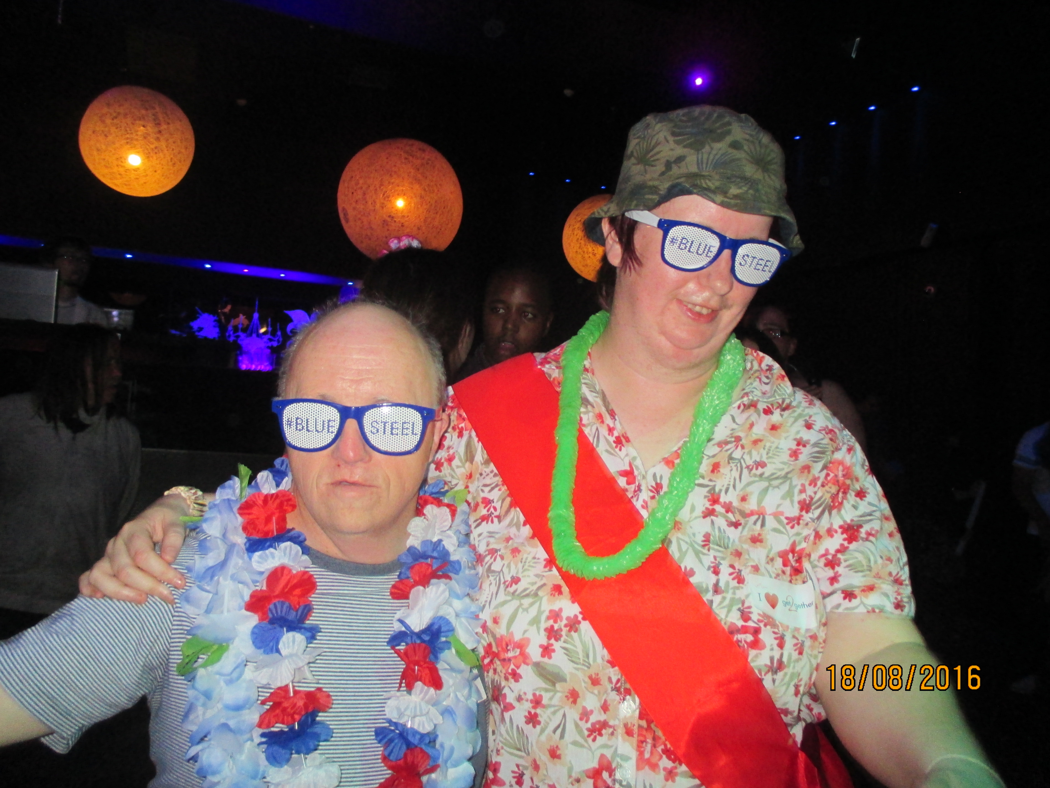


This Summer, Smart Talk has had to say farewell to Laura. She is moving to a new job with East Lothian Council.

Laura has been a great support to Mhairi at meetings. She has also been a great help to everyone who attends Smart Talk.

We will miss her, but wish her all the best in her new job.

We now look forward to getting to know Coral, Mhairi’s new support worker.
Bye Bye Laura
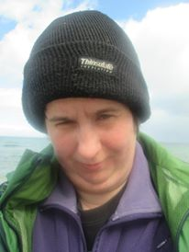

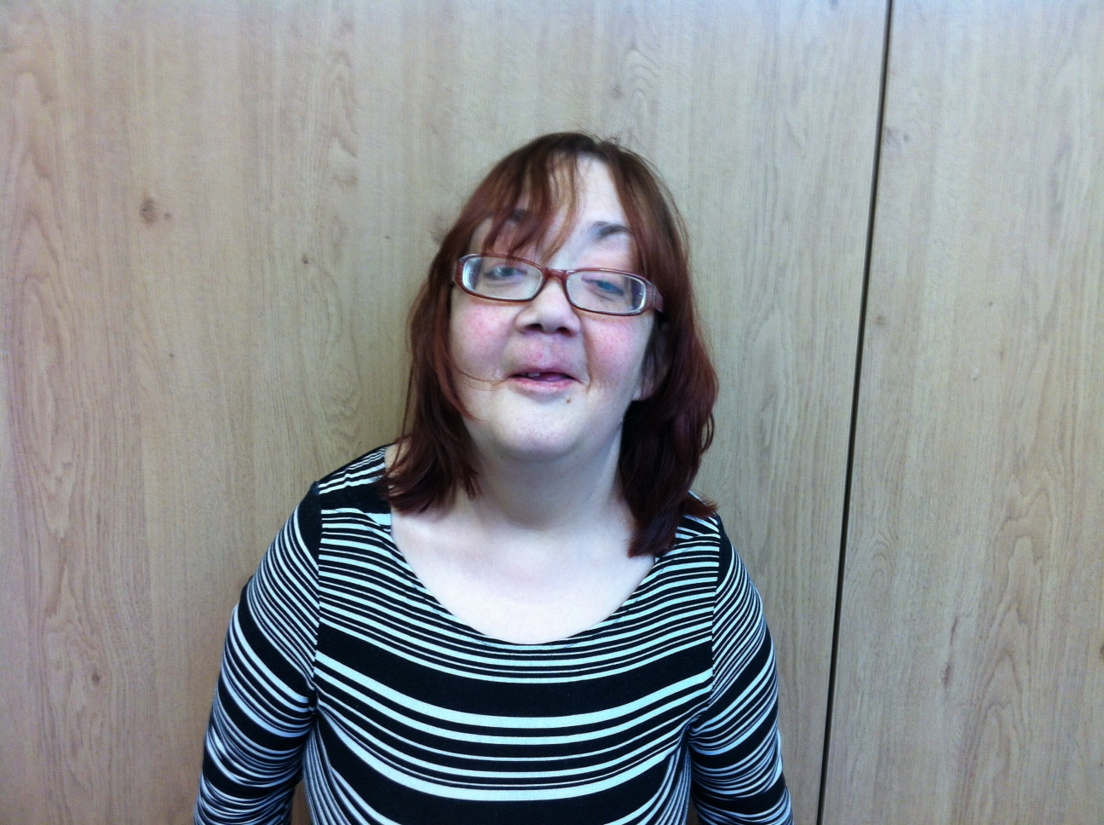

Colin has been travelling all around England this Summer, following the stockcar racing.
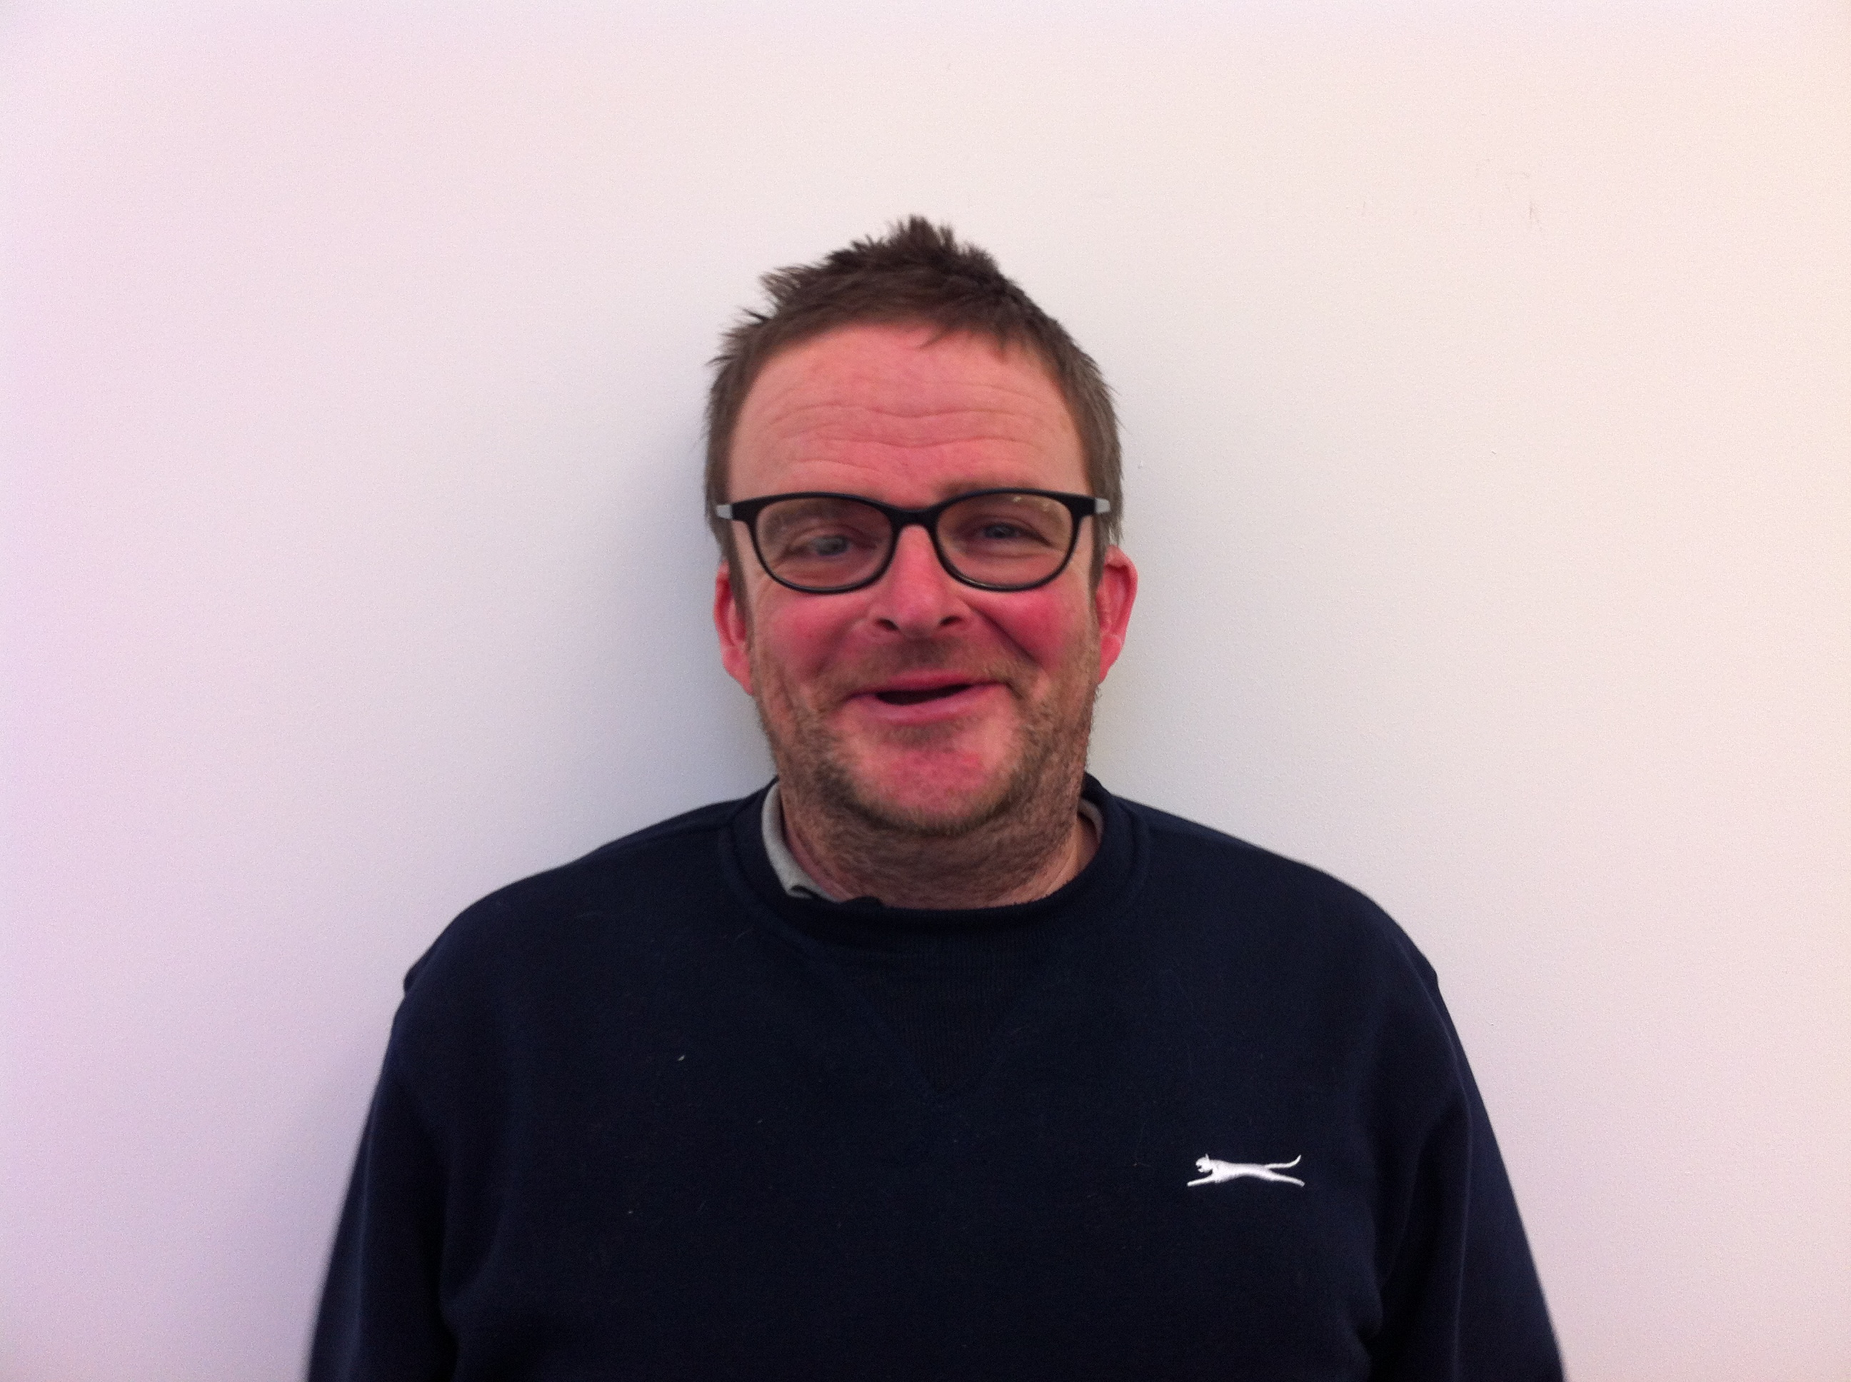

Elaine and Lewis think East Coast Buses are comfy and quicker. Malcolm didn’t know the bus times have changed.
Michael is going off to another Dr Who convention. Maybe Michael should become the next Dr Who.
Kevin is going away to Fort William for a wee holiday with Upward Mobility.
Sarah has been away on the island of Gigha, doing some more conservation work with The Woodland Trust.
Janice is feeling more independent, after her eye operation. She now feels safer travelling on buses.
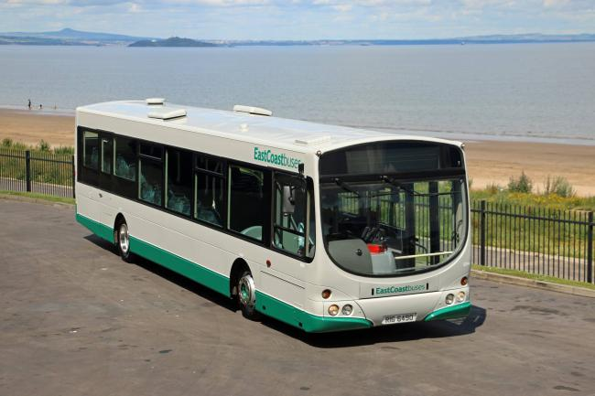

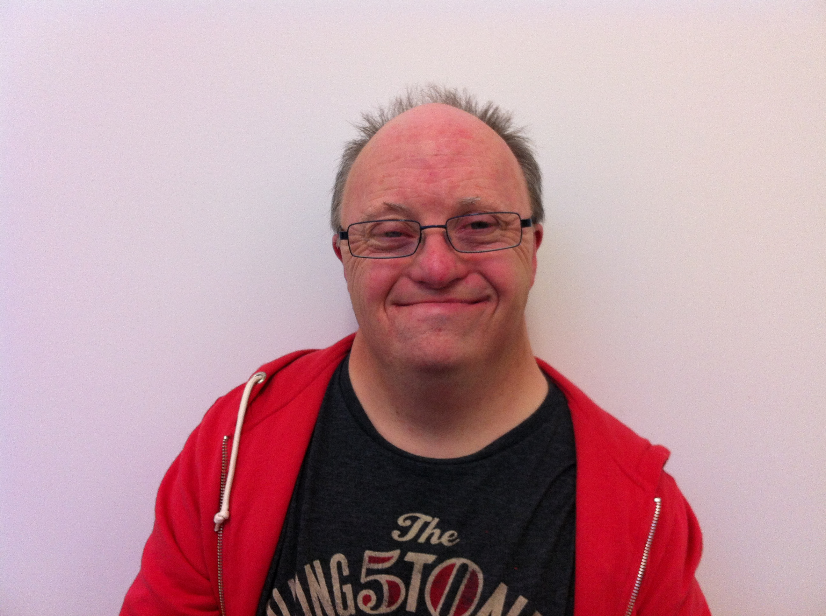



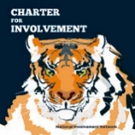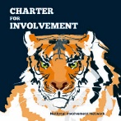
Ryan and Colin attended a National Involvement Network (NIN) meeting in Edinburgh. They met people from all over Scotland. The NIN is trying to promote The Charter in Scotland.

This is all about promoting people’s rights in making decisions about the care they receive.

The next meeting is in September, in Perth.
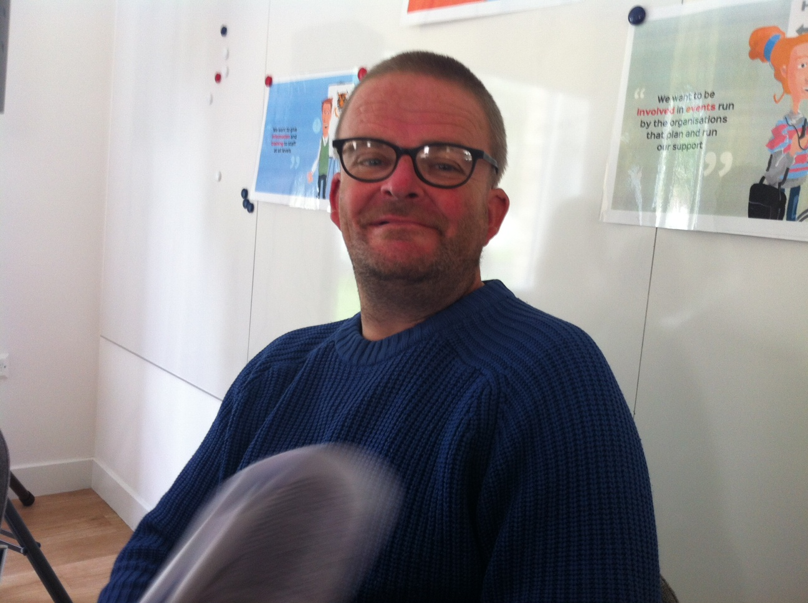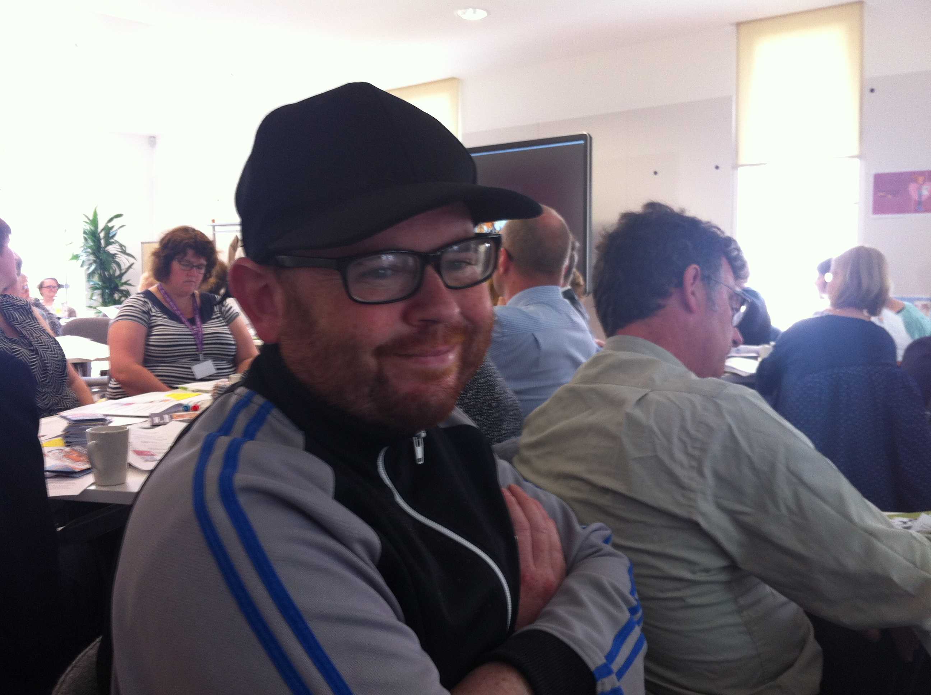

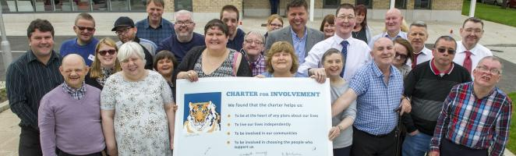
This month, East Lothian Council set up a workshop, to hear the views of service users who use the Care At Home Service.
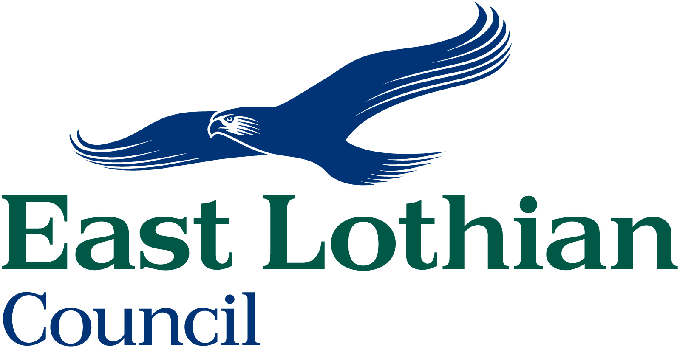
Staff from the Social Work Department met with a number of people about what they thought about their care service. What works well? What could make care better?
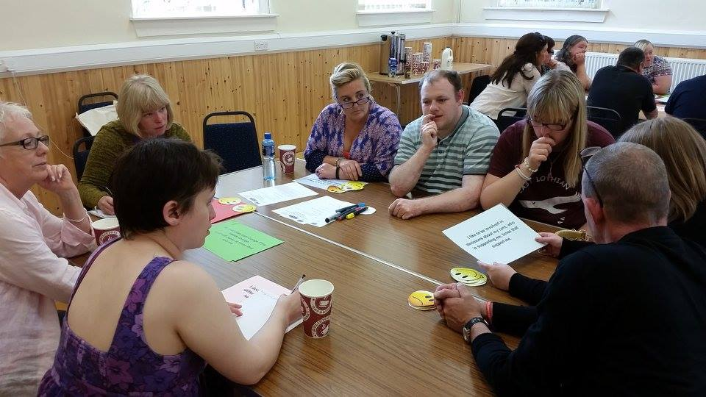
The comments people made will help the Council choose which care organisations should be offered new contracts.
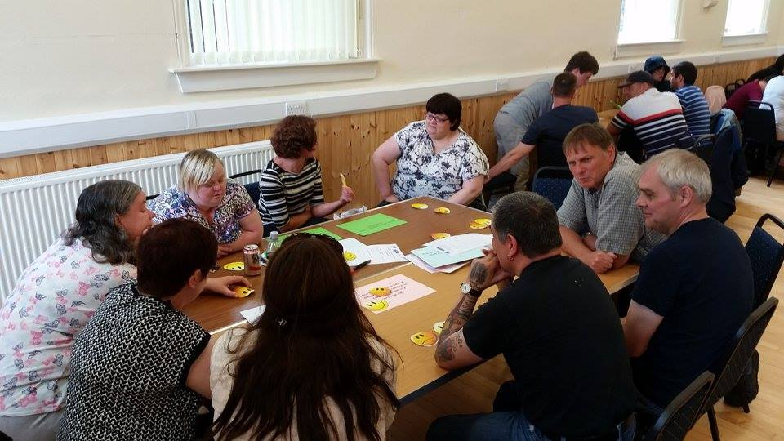
Care At HOME
Outdoor Activities With Beyond Boundaries

Over the last few weeks, Beyond Boundaries East Lothian (BBEL) have been busy offering outdoor activities to people with disabilities. Some Smart Talk members have enjoyed canoeing, water boarding and cycling.
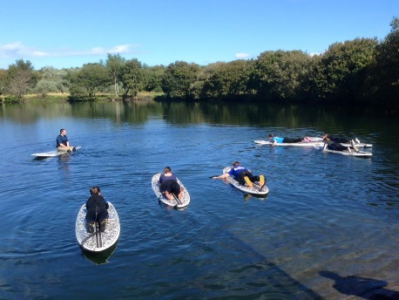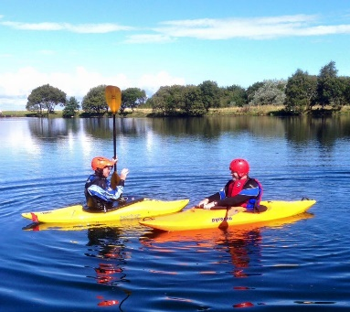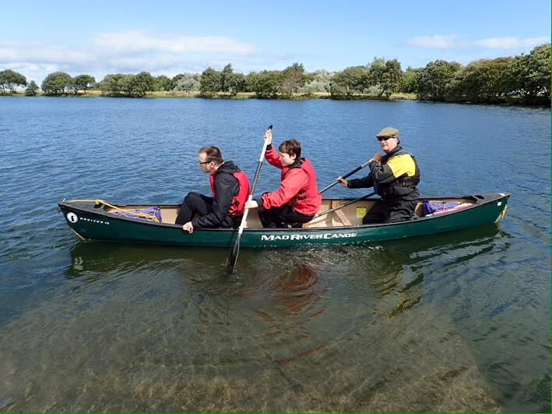
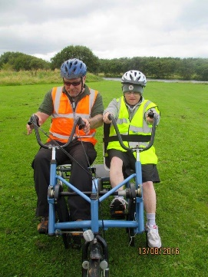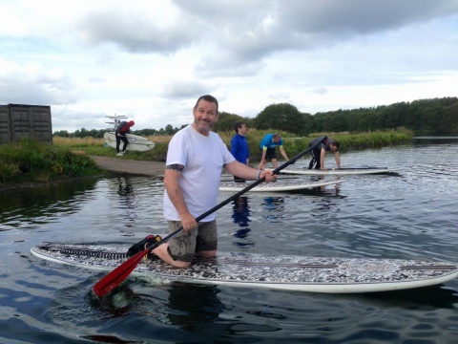
Steve Nelson, who runs BBEL would like to offer more opportunities for people to enjoy outdoor activities. But to do this he needs funding. He plans to apply for grants to run BBEL. It will help him if lots of people let him know they are interested in doing outdoor activities.

If you would like to have fun trying out cycling, mountaineering and water sports, get your carer to contact Steve Nelson on - bbel1@btinternet.com
For more information, look at http://www.bbel.org.uk/ and on Facebook https://www.facebook.com/beyondboundaries.eastlothian

Smart Talk Dates
George Johnstone Centre, Tranent | MECA, Musselburgh
 | 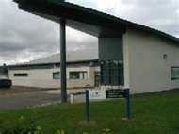
September 14th – 1pm - 3pm | September 7th
September 28th – No Meeting | September 21st
October 12th – 1pm - 3pm – Joint Meeting | October 5th
October 26th – 1pm - 3pm | October 19th
November 9th – No Meeting | November 2nd
November 23rd – 1pm - 3pm | November 16th
December 7th | November 30th
December 21st – Joint Meeting | December 14th
January 4th 2017 | January 11th 2017
January 18th | January 25th

For more information on Smart Talk, contact Andy Murray on
07794 325590 or andy@partnersinadvocacy.org.uk


