|  |  |  |
| --- | --- | --- |
|  | Headway  East Lothian  SC10  Newsletter  www.headway-eastlothian.org.uk |  |
| Issue 16/09 | Honorary President  Dr Alasdair Fitzgerald | September 2016 |

Thursday 29th September 2016 11.00am – 3.00pm

Halhill Healthy Living Centre, Kellie Road, Dunbar, East Lothian EH42 1XB

Headway East Lothian would like to invite you to our first Challenge Day

Refreshments will be available all day

Challenges will include - Boccia New Age Kurling Dominoes

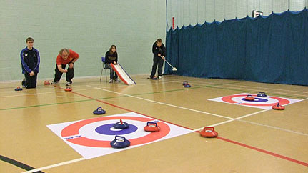 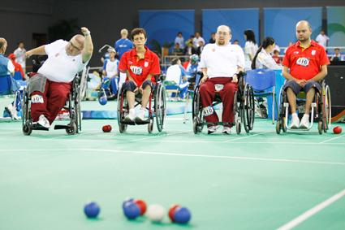

Come along & enjoy the fun & cheer on our members, volunteers and supporters as they take on their own challenge – a sponsored all ability walk of as many laps of the rugby pitch as they can manage!

RSVP to Joyce by phoning or texting 07895 193974

|  |
| --- |
| Lloyds TSB Foundation  awards-for-all-logo |

e-mail headwayeastlothian@live.co.uk

Noticeboard

|  |  |
| --- | --- |
|  | Carer meetings held on Mondays as required |
|  | Relaxation classes held on Mondays as required |
| meeting-room | Next Board Meeting  Wednesday 26th October  Haddington |
| NEXT  OUTING | Friday  14thOctober  Christmas Shopping Livingston |



Celebrate Success Awards

All welcome to come along to the Doughty Centre, Herdmanflat Hospital, Aberlady Road, Haddington, Wednesday 7th September 7.00pm onwards!

There will be light refreshments on offer, a chance to mingle and chat and of course the announcement of our very own awards for those who have achieved goals small or large; furthered the work of Headway in the community and helped us during the year

Christmas

Christmas Shopping trip to Livingston will be on Friday 14th October; book your place on the bus now with Joyce or at any of the meetings.

Details of Christmas Lunch will be announced soon!



## THE SEVEN AGES OF ABI The Impact of Acquired Brain Injury Across the Lifespan

**SHIF Event, Aberdeen, Book Now!**

SHIF are pleased to announce that bookings are now open for our event on the 22nd of September in Aberdeen, "**The Seven Ages of ABI - The Impact of Acquired Brain Injury Across the Lifespan**". A fascinating day is planned, featuring speakers covering issues from Infants, schooling, teenagers, work, relationships, parenting and Geriatric Care - a full day indeed! Our next email will contain a full list of speakers, but in the meantime....  
This year we have a new venue, conveniently just next door to where we have held our events over the last 2 years! The event is being held at;   
[**The Rox Hotel, 17- 23 Market St, Aberdeen AB11 5PY**](http://shif.us8.list-manage.com/track/click?u=97eaa80a6b7bd8239d692e6bc&id=c3a9557eec&e=e76ab4cd3c)  
**To book your place, simply click reply to this email and let us know how many places you require.**  
Members - Free  
Non-Members - £40  
People with ABI and Carers - Free  
As with our previous venue, The Rox Hotel is conveniently located within a 10 minute walk of Aberdeen Train Station.   
Registration will open at 9.30am, with talks finishing no later than 4.00pm, and as always we have plenty of exhibitors and opportunities to network.

This month at Headway

|  |  |  |  |
| --- | --- | --- | --- |
| 1 | Thu | Dunbar | News round up |
| 2 | Fri |  |  |
| 3 | Sat |  |  |
| 4 | Sun |  |  |
| 5 | Mon | Musselburgh | Dominoes & Chat |
| 6 | Tues | Glasgow | Scottish Development Committee |
| 7 | Wed | Haddington | Celebrate Success Awards |
| 8 | Thu | Dunbar | Autumn/Winter Planning |
| 9 | Fri |  |  |
| 10 | Sat |  |  |
| 11 | Sun |  |  |
| 12 | Mon | Musselburgh | Dominoes & Chat |
| 13 | Tues |  |  |
| 14 | Wed | Haddington | Games & Wii |
| 15 | Thu | Dunbar | Games & puzzles |
| 16 | Fri |  |  |
| 17 | Sat |  |  |
| 18 | Sun |  |  |
| 19 | Mon | Musselburgh | Carers in the Cafe @ 2.00pm |
| 20 | Tues |  |  |
| 21 | Wed | Haddington | Autumn/Winter Planning |
| 22 | Thu | Dunbar | Activities Day |
| 23 | Fri |  |  |
| 24 | Sat |  |  |
| 25 | Sun |  |  |
| 26 | Mon | Musselburgh | Autumn/Winter Planning & dominoes |
| 27 | Tues |  |  |
| 28 | Wed | Haddington | Chip Shop Challenge |
| 29 | Thu | Dunbar | Challenge Day |
| 30 | Fri |  |  |
| 31 | Sat |  |  |

Meetings

**Monday T**he Musselburgh East Community Association (MECA) building,

Wallyford Road, just up from Levenhall roundabout 1pm - 4pm. A chance to meet over a cup of coffee. There is a café where lunch or a snack can be purchased.

**Wednesday T**he Doughty Centre Herdmanflat Hospital Aberlady Road Haddington at 6.30pm Wednesday evenings with a speaker etc. The meeting finishes at 8.30pm.We are not connected to the hospital.

Th**ursday** we meet at Hallhill Healthy Living Centre, Dunbar on a Thursday

12 noon- 2pm for those who live in Dunbar and surrounding area.

Contact Us

|  |  |
| --- | --- |
| Jim Maryniak  Convener | 07920 195743  [jimmaryniak@hotmail.com](mailto:jimmaryniak@hotmail.com) |
| Richard Fairbairn  Treasurer | 077604 95851  [james.fairbairn123@btinternet.com](mailto:james.fairbairn123@btinternet.com) |
|  |  |
|  |  |
| Development Officer  Joyce Cattanach | 07895 193974  [headwayeastlothian@live.co.uk](mailto:headwayeastlothian@live.co.uk) |

Joyce is also available at The Bleachingfield Centre, Countess Crescent, Dunbar, EH42 1DX, by appointment, Mondays, Tuesdays & Wednesdays and for outreach at other times.

Items for the newsletter to Robert Dalrymple [robert.dalrymple202@btinternet.com](mailto:robert.dalrymple202@btinternet.com) Tel 01620 844020



Improving life after brain injury Charity No **SC035535**

Next Board

Meeting



1.30 pm MECA

in January tbc