**Port Seton Resource Centre Newsletter 2015**

**“Recent Events”**

**SU Conference**

The Members Council, which is run by people who attend the centre, with a little help from Andy Murray, their independent advocate, organised a conference around “My Life” principals. The day revolved around what consists of an ordinary day and what activities, social events and leisure pursuits they could come up with to enhance and improve their day. For break after tea and coffee we also had the biggest Zumba class ever.

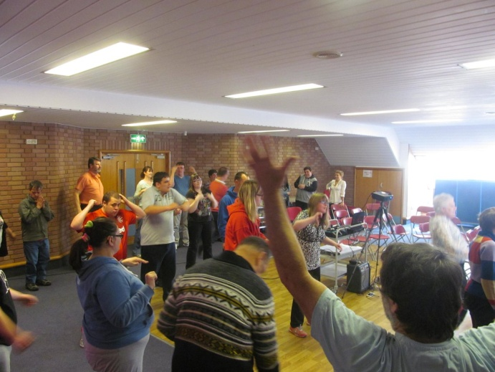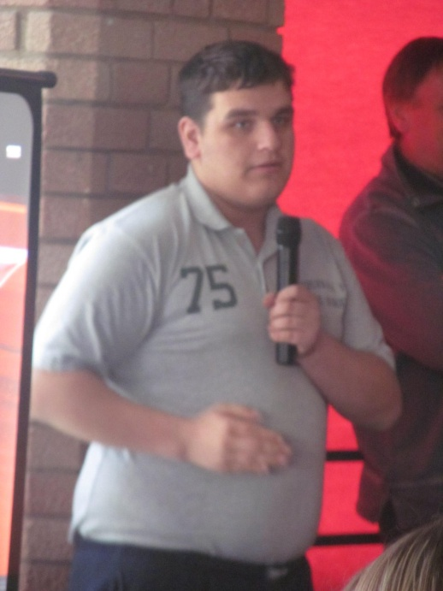

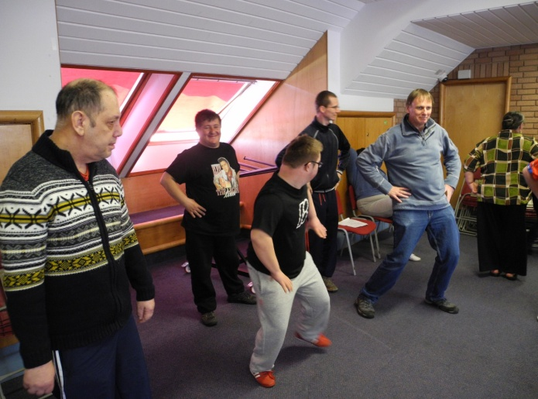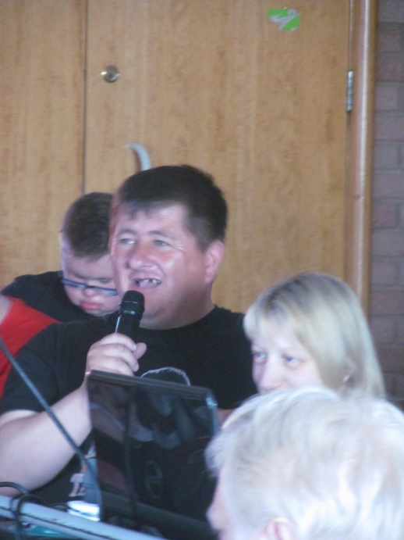

**East Coast FM**

A one of visit to East Coast FM was a highlight for some of the folks who attend Port Seton. I’m sure a few stars were created. Who knew we had such natural talent lurking here? While the folks in this group were busy being interviewed and extolling the virtues of Justin Bieber and High School Musical all the rest of us back at the centre had a grand old time recognising their voices in amazement and playing spot the celebrity.

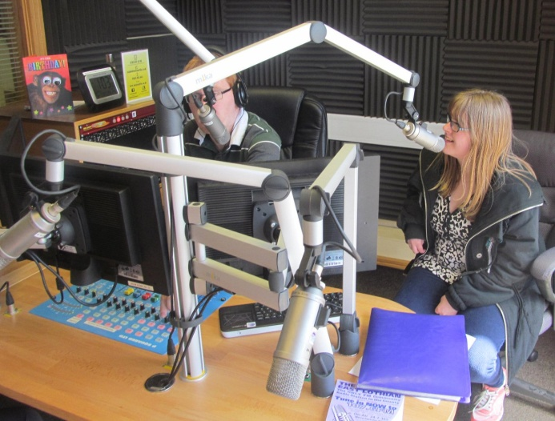

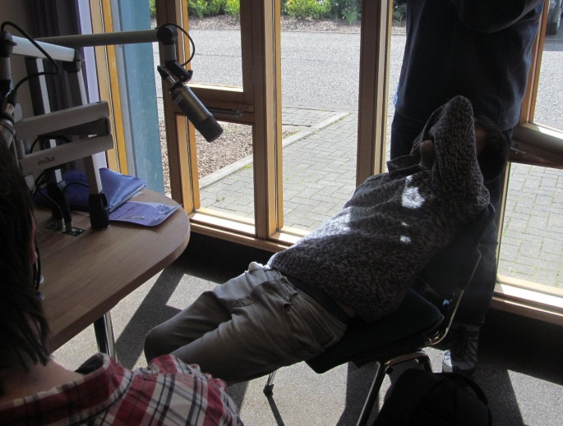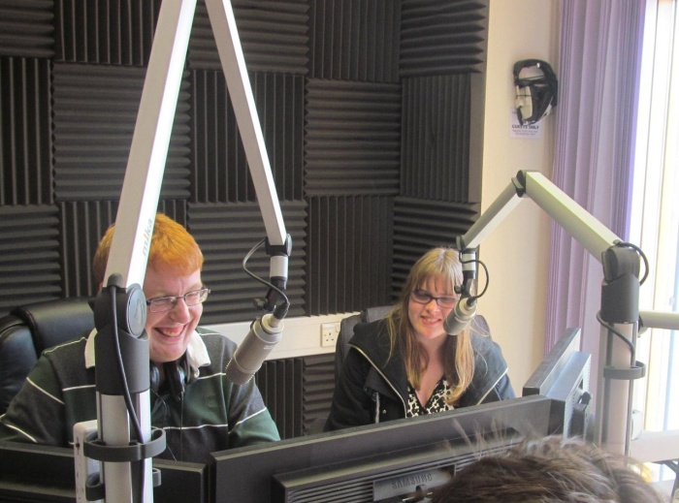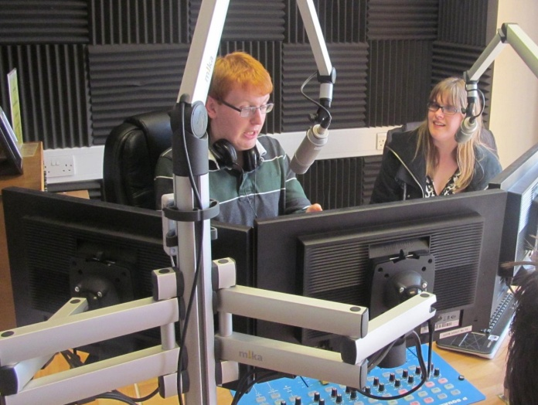

If you want to experience the whole video interview, go to our web site at the link below:

<http://psrc.org.uk/index.php/2015/days-out/treasure-hunters-2015-east-coast-fm>

**New PSRC Group Activity**

* **SeasideArtsnCrafts.gifSeasideArtsnCrafts.gifSeaside Arts n Crafts -**

The Seaside Arts n Crafts Group is a very busy and talented group. They have decorated bottles with sand and paints and glues. They have made shellfish, jellyfish and tropical fish. When possible the group uses stuff from the beach or any old materials they can dream up sourced from who knows where, a really resourceful group. I like the wee beach hut designs they are currently working on.

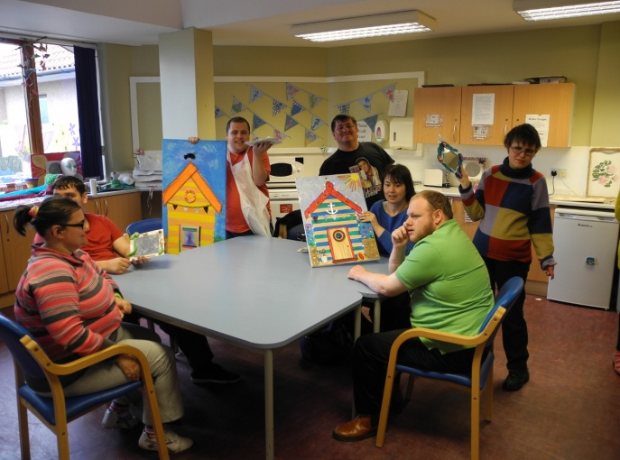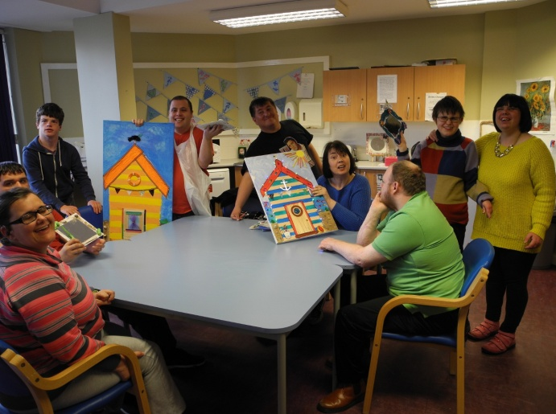

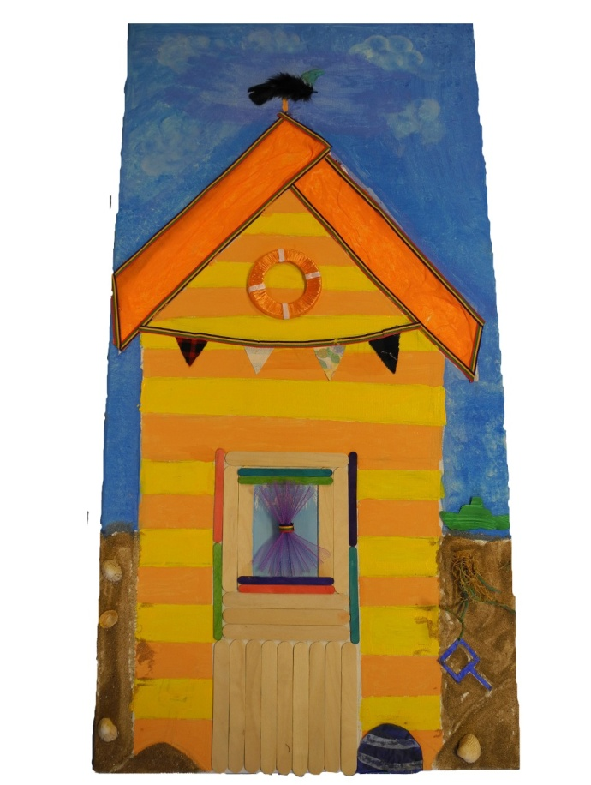

**INFORMATION**

**After Summer Party Blues – PS Bowling Club**

Could all staff, carers and service users please contact the centre if they would like to come to our Post Summer Madness Disco? It’s on Friday 28th August 2015 in the Port Seton Bowling Club, 7:00 to 10:00, closes 11:00. Like the party for Jackie this will also be a celebration of life for our recently departed Louise. Wear something blue but don’t be blue.

**Fisherrow Hub Evening Drop-In Dates and Times**

An evening of fun, relaxation and social activities. Dates for Fisherrow Hub in Musselburgh are:

* Thursday 2nd , 16th and 30th July 2015 6:00 to 8:30
* Thursday 13th and 27th Aug 2015 6:00 to 8:30
* Thursday 10th and 24th Sept 2015 6:00 to 8:30
* Thursday 8th and 22nd Oct 2015 6:00 to 8:30
* Thursday 5th and 19th Nov 2015 6:00 to 8:30
* Thursday 3rd and 17th Dec 2015 6:00 to 8:30

**Tynebank Tynezone Social Club Dates and Times**

Dates for Tynezone at Nungate, Haddington are:

* Wednesday 8th and 22nd July 2015 6:30 to 8:30
* Wednesday 5th and 19th Aug 2015 6:30 to 8:30
* Wednesday 2nd , 16th and 30th Sept 2015 6:30 to 8:30

**Port Seton Resource Centre Web Site**

As ever information on recent and previous groups and activities can be found by using our web site.

Here is the URL: <http://psrc.org.uk/>

**Fixed Public Holidays:**

PSRC closed - Friday 18th and Monday 21st Sept 2015

PSRC closed - Friday 25th Dec 2015 to Monday 4th Jan 2016 inc.

**Email communication:**

Anyone wishing to receive communication/information using email, please contact Bruce or Mike using email info below. Thanks.

**Get2Gether Launch Party**

Get2Gether and East Coast Fm are holding an East Lothian Launch Party at Haddington Corn Exchange. The party is on Friday 31st July 2015 from 7pm to 10pm. Contact 075511 25726 for tickets and information.

**Telephone Survey Results 2015**

Please find enclosed with our newsletter a brief summary from our telephone survey carried out in June 2015. From this we have agreed to try and contact every parent/carer to check our records of phone no, address and email is correct. If any of these details change it would be appreciated if you could inform us by any of the contact details given below. We realise the taxi times are a bit erratic and sometimes late so we have contacted the company to try and resolve this. We will keep you informed as soon as we can. Thanks.

**Contact Details:**

Phone : 01875 818175

Email: [bsmith@eastlothian.gov.uk](mailto:bsmith@eastlothian.gov.uk)

Email: [mveitch@eastlothian.gov.uk](mailto:mveitch@eastlothian.gov.uk)