|  |  |  |
| --- | --- | --- |
|  | Headway  East Lothian  SC10  Newsletter |  |
| Issue 15/07 | Honorary President  Dr Alasdair Fitzgerald | July 2015 |

Golf Tournament

Saturday 20th June

Winterfield Golf Course Dunbar

Thanks to the Organiser Davy Dickson, Kate and Jackie and all others who helped in any way to make the day such a success.

The marvellous sum of £1820 was raised.

|  |
| --- |
| awards-for-all-logoLloyds TSB Foundation |

|  |  |
| --- | --- |
|  | Carer meetings held on Mondays as required |
|  | Relaxation classes held on Mondays as required |
| meeting-room | Next Board Meeting  Wednesday 15th July  Haddington |
|  | Look forward to our Annual BBQ at Gordon & Dottie’s, Friday 7th August, 12.00pm – 3.00pm – contact Joyce, Gordon or Dottie if you intend to come along! |
| ANNUAL LEAVE | Joyce on Annual Leave from Monday 13th  – Friday 24th July inclusive |
|  | Best Wishes Jan  We are all thinking of you  and waiting you to come back |

Family Fun Quiz Day

Thanks to all who attended; it was a great afternoon & evening! The quiz was won by the ‘Scrambled Egg Heads’ with one of the Headway teams a close runner up! Thanks to Fiona Grant-MacDonald for arranging the venue and providing the entertainment, to Irene Grant for helping to sell the tickets and to the Staff and Customers of the Thorntree inn for providing the buffet and buying raffle tickets. The money raised will be added into Fiona’s total for her fundraising efforts throughout the year; next up is the Alternative 3 Peaks event, more details to follow

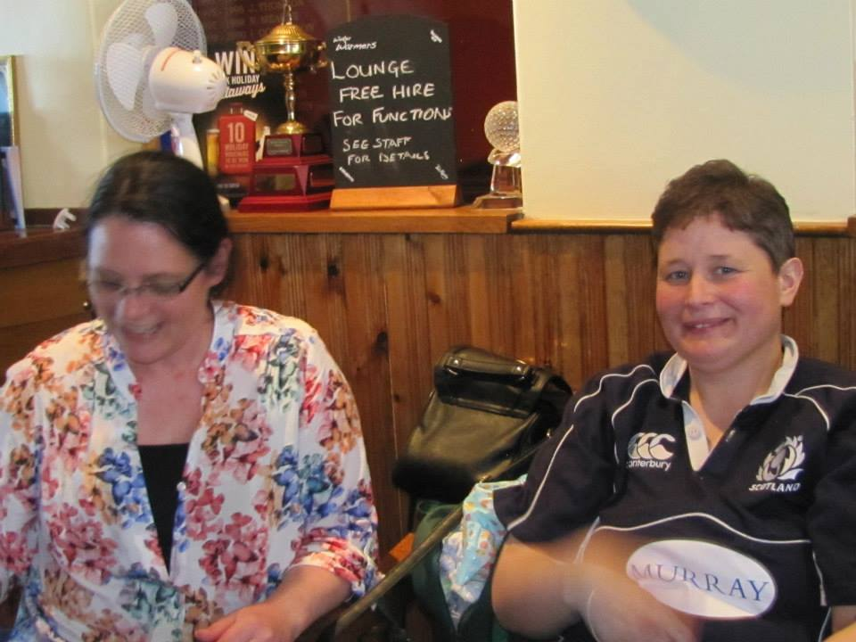

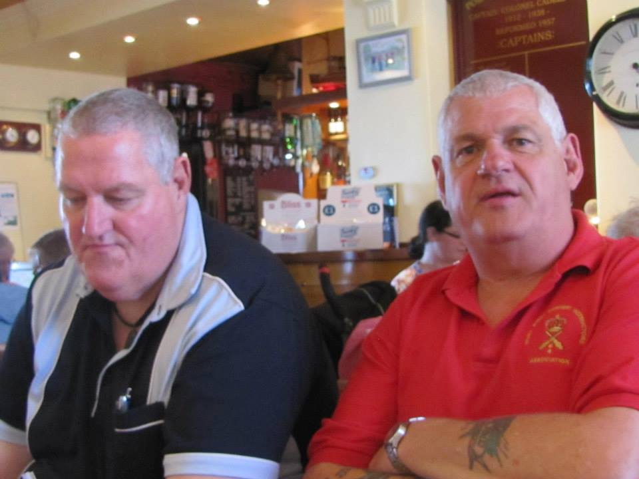

From the Archive

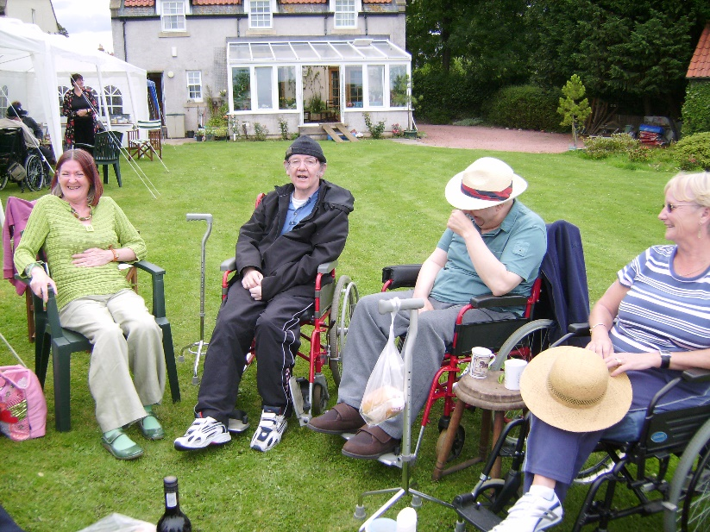

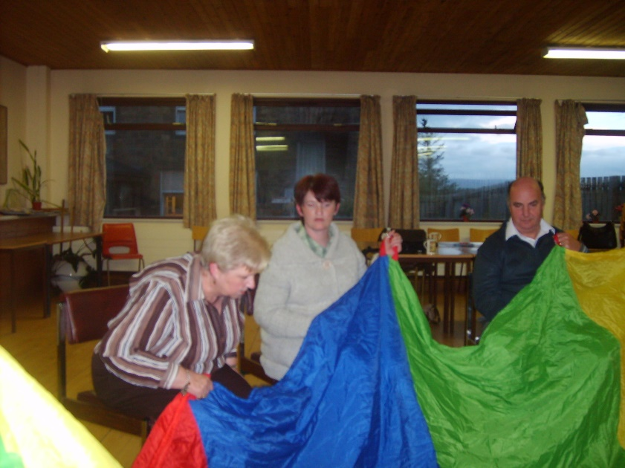

This month at Headway

|  |  |  |  |
| --- | --- | --- | --- |
| 1 | Wed | Haddington | Patricia Eckersley – exercise session |
| 2 | Thu | Dunbar | Table Games |
| 3 | Fri |  |  |
| 4 | Sat |  |  |
| 5 | Sun |  |  |
| 6 | Mon | Musselburgh | Dominoes Tournament |
| 7 | Tues |  |  |
| 8 | Wed | Haddington | Minutes, Code of Conduct - Joyce |
| 9 | Thurs | Dunbar | Exercise Session – Joyce |
| 10 | Fri |  |  |
| 11 | Sat |  |  |
| 12 | Sun |  |  |
| 13 | Mon | Musselburgh | Dominoes and chat |
| 14 | Tues |  |  |
| 15 | Wed | Haddington | Board Meeting, Games & Wii |
| 16 | Thurs | Dunbar | Games |

|  |  |  |  |
| --- | --- | --- | --- |
| 17 | Fri |  |  |
| 18 | Sat |  |  |
| 19 | Sun |  |  |
| 20 | Mon | Musselburgh | Dominoes and chat |
| 21 | Tues |  |  |
| 22 | Wed | Haddington | Patricia Eckersley – exercise session |
| 23 | Thurs | Dunbar | Games |
| 24 | Fri |  |  |
| 25 | Sat |  |  |
| 26 | Sun |  |  |
| 27 | Mon | Musselburgh | Andy Brown – Joyce |
| 28 | Tues |  |  |
| 29 | Wed | Haddington | Patricia Eckersley – exercise session |

Meetings

**Monday T**he Musselburgh East Community Association (MECA) building,

Wallyford Road, just up from Levenhall roundabout 1pm - 4pm.A chance to meet over a cup of coffee. There is a café where lunch or a snack can be purchased.

**Wednesday T**he Doughty Centre Herdmanflat Hospital Aberlady Road Haddington at 6.30pmesday evenings with a speaker etc. The meeting finishes at 8.30pm.We are not connected to the hospital.

Th**ursday** we meet at Hallhill Healthy Living Centre, Dunbar on a Thursday

12 noon- 2pm for those who live in Dunbar and surrounding area.

Contact Us

|  |  |
| --- | --- |
| Jim Maryniak  Convener | 07920 195743  [jimmaryniak@hotmail.com](mailto:jimmaryniak@hotmail.com) |
| Gordon Wallace  Treasurer | 01875 853491  [csgordon.wallace@virgin.net](mailto:csgordon.wallace@virgin.net) |
| Gordon Wallace  Acting Secretary |  |
| Development Officer  Joyce Cattanach | 07895 193974  [headwayeastlothian@live.co.uk](mailto:headwayeastlothian@live.co.uk) |

Joyce is also available at The Bleachingfield Centre, Countess Crescent, Dunbar, EH42 1DX, by appointment, Mondays, Tuesdays & Wednesdays and for outreach at other times.

Items for the newsletter to Robert Dalrymple r[obert.dalrymple202@](mailto:obert.dalrymple202@)btinternet.com Tel 01620 844020



Improving life after brain injury Charity No **SC035535**

**Affiliated to Headway – the brain injury association**

Next Board

Meeting



1.30 pm MECA

in January tbc