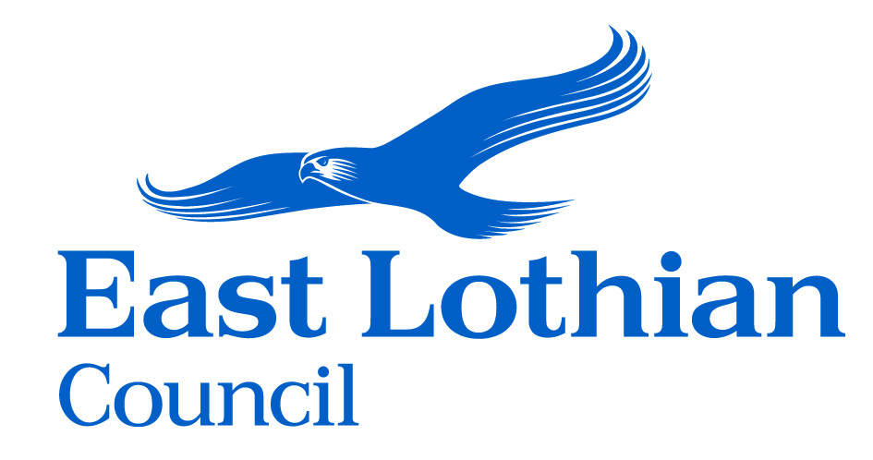

**CONSENT CARD**

**Port Seton Resource Centre (PSRC) Web Site -** [**https://psrc.org.uk/**](https://psrc.org.uk/)

**Facebook Fan Page** [**https://www.facebook.com/psrcno1fans**](https://www.facebook.com/psrcno1fans) **Promotional Material used during Open Days and Centre Activities**

This card is for use by persons 13 and older who are participating in the above-named projects. We value your participation and seek your consent to use photographs and/or video and/or audio recordings of you.

Any information (including photos, video and audio) we have will be held in accordance with the General Data Protection Regulation (GDPR). The personal data collected on this card will be held securely and will only be used for administrative purposes relating to your consent.

You have the right to request a copy of the information we hold on you and to request corrections or deletions of it. You can ask PSRC or East Lothian Council to stop using your photos, video or audio at any time, in which case they will not be used in future publications and will be withdrawn from any digital media but may continue to appear in publications already in circulation.

You will be given a copy of this card to keep.

PSRC and East Lothian Council are both ‘data controllers’ for your information and can be contacted at any time:

PSRC Data Protection Officer

South Seton Park East Lothian Council

Port Seton John Muir House, Brewery Park

EH32 0BQ Haddington, EH41 3HA

e: [bsmith@eastlothian.gov.uk](mailto:bsmith@eastlothian.gov.uk) e: [dpo@eastlothian.gov.uk](mailto:dpo@eastlothian.gov.uk)

t: 01875 818 177 t: 01620 827 827

Please tick all boxes that apply:

I agree to allow PSRC / East Lothian Council to take photographs and/or videos and/or audio recordings of me at any stage during the project.

I grant permission for these to be used in print and in presentations made by PSRC and East Lothian Council for project evaluation, reporting, training, research purposes, and promotional activities.

I grant permission for these photographs and/or videos and/or audio recordings to be used digitally on websites and on social media by PSRC and East Lothian Council for promotional purposes.

I understand that I have the right to withdraw my consent at any time by contacting PSRC or East Lothian Council using the details above.

For more information about your rights, how and why we use your information, and how long your information will be kept, please contact the Data Protection Officer at East Lothian Council.

Your name (PRINT):

Date:

Signature: